

***CONTAINERS AND DOCKERS***

***Submitted by:***

***NAME: Tanishqua Tellakula***

***SAP ID: 500084269***

***Roll number :R120220007***

***Batch: B1(Hons)***

***Lab Exercise 4- Working with Docker Networking***

***Step 1: Understanding Docker Default Networks***

*Docker provides three default networks:*

* *bridge: The default network when a container starts.*
* *host: Bypasses Docker’s network isolation and attaches the container directly to the host network.*
* *none: No networking is available for the container.*

***1.1. Inspect Default Networks***

*Check Docker's default networks using:*

|  |
| --- |
| ***docker network ls*** |

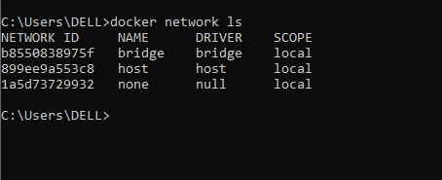

***1.2. Inspect the Bridge Network***

|  |
| --- |
| ***docker network inspect bridge*** |

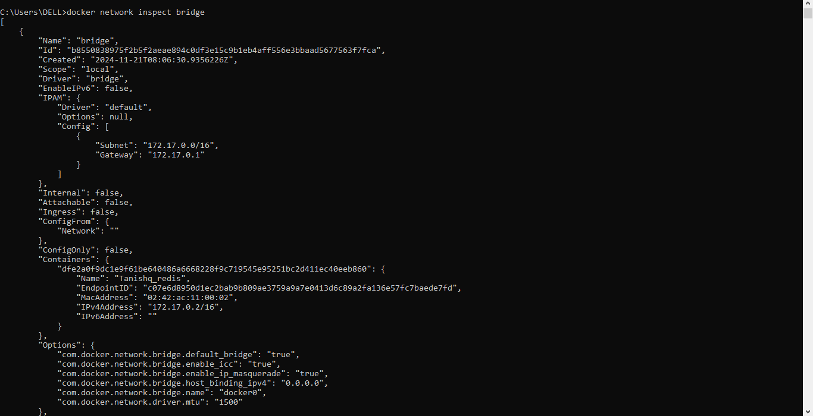

*This command will show detailed information about the bridge network, including the connected containers and IP address ranges.*

***Step 2: Create and Use a Bridge Network***

***2.1. Create a User-Defined Bridge Network***

*A user-defined bridge network allows containers to communicate by name instead of IP.*

|  |
| --- |
| ***docker network create my_bridge*** |



***2.2. Run Containers on the User-Defined Network***

*Start two containers on the newly created my_bridge network:*

|  |
| --- |
| ***docker run -dit --name container1 --network my_bridge busybox***  ***docker run -dit --name container2 --network my_bridge busybox*** |



***2.3. Test Container Communication***

*Execute a ping command from container1 to container2 using container names:*

|  |
| --- |
| ***docker exec -it container1 ping container2*** |

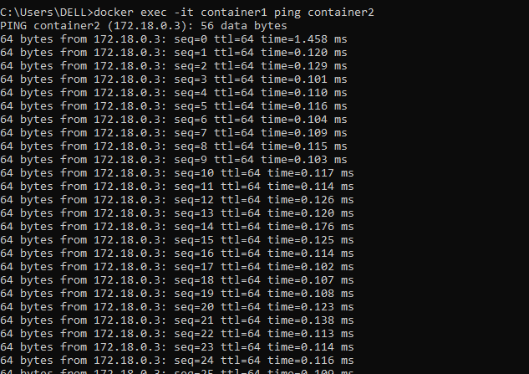

*The containers should be able to communicate since they are on the same network.*

***Step 3: Disconnect and Remove Networks***

***3.1. Disconnect Containers from Networks***

*To disconnect container1 from my_bridge:*

|  |
| --- |
| ***docker network disconnect my_bridge container1*** |

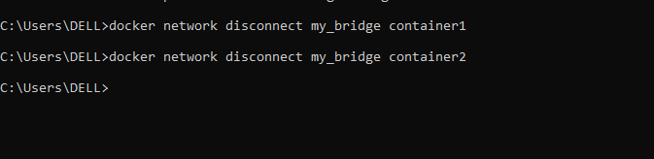

***4.2. Remove Networks***

*To remove the user-defined network:*

|  |
| --- |
| ***docker network rm my_bridge*** |

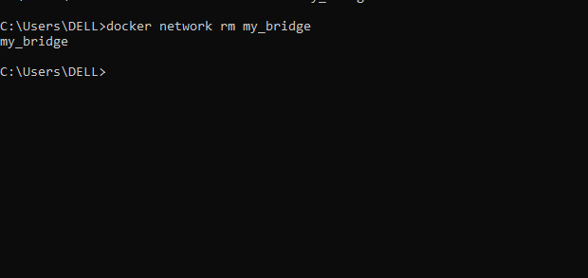

***Step 4: Clean Up***

*Stop and remove all containers created during this exercise:*

|  |
| --- |
| ***docker rm -f container1 container2*** |

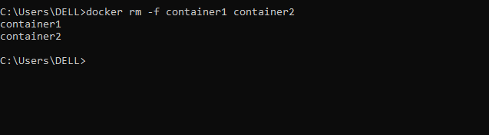

*Now check if all are removed*

